INDUSTRIAL TRAINING PROJECT REPORT

“HOUSE PREDICTION SYSTEM”

Submitted in the partial fulfilment of the requirement for the award of degree of

Bachelor of Technology

In

Computer Science and Engineering

Batch

(2023-2027)



Submitted to: MS. RIDHI KAPOOR
Submitted by : SUDHANHSU DADHWAL Registration No : -12300386

DEPARTMENT OF COMPUTER SCIENCE AND ENGINEERING

DAV UNIVERSITY JALANDHAR- PUNJAB 144012

CERTIFICATE OF COMPLETION



ACKNOWLEDGEMENT

I, Sudhanshu Dadhwal, student of the Department of Computer Science and

Engineering , DAV University, express my sincere gratitude for the support and

guidance extended to me during the completion of my project “HOUSE

PREDICTION SYSTEM”

My heartfelt thanks go to Mr. Naresh sir for their invaluable guidance,

continuous support, and deep insights throughout the development of this

project. Their mentorship played a crucial role in shaping the project,

strengthening its ideas, and guiding it in the right direction. Their dedication

and collaborative approach greatly contributed to the successful execution of

this work.

Lastly, I am deeply grateful to everyone who directly or indirectly

contributed to the successful completion of this project. Your support has

been truly meaningful, and I sincerely appreciate it.

DECLARATION
I, SUDHANSHU DADHWAL , a student of the Department of Computer Science, DAV University, hereby declare that the project titled “HOUSE PREIDICTION” has been carried out by me under the guidance and support of my mentors and faculty.

I affirm that this project is an original work completed by me and has not been submitted, in part or full, for any other degree, diploma, or certification at any institution or university. All the information, data, and results presented in this report are genuine and based on my independent effort, except where references have been clearly cited.

I take full responsibility for the authenticity of the content and the work presented in this project.

Name: SUDHANSHU
Department: Computer Science and Engineering
University: DAV University

INDEX
CONTENT | PAGE NO
COMPANY PROFILE | 6
ABSTRACT | 7
INTRODUCTION | 8
OBJECTIVE | 9
DESCRIPTION | 10-11
TOOLS AND TECHNOLOGY | 12-18
IMPLEMENTATION | 19-20
APPLICATIONS | 21-22
FUTURE GOALS | 23-24
CONCLUSION | 25
References | 26



COMPANY PROFILE

Excellence Technology , based in Mohali, Punjab, is a prominent IT and software development company recognized for delivering modern, efficient, and scalable digital solutions. The company serves clients across various industries by providing high-quality technology services tailored to meet global requirements. With a reputation for reliability and innovation, Excellence Technology has established itself as a trusted technology partner in both domestic and international markets.

The organization specializes in a diverse range of services, including web development, mobile application development, custom software solutions, UI/UX design, quality assurance and testing, CMS development, and digital marketing. Backed by a team of experienced developers, designers, and IT professionals, the company focuses on delivering performance-driven solutions that align with the latest industry trends. Their commitment to quality and customer satisfaction is reflected in every stage of the development process, from planning and design to deployment and maintenance.

Through a combination of innovation, technical expertise, and customer-centric solutions, Excellence Technology continues to contribute significantly to the technology industry. The company’s dedication to excellence and continuous improvement has helped it build long-term relationships with clients while fostering a culture of learning and growth within the organization.
ABSTRACT

The rapid growth of the real estate sector has created a strong need for accurate and data-driven price estimation tools. This project, “House Price Prediction Using Machine Learning,” aims to build a predictive model that estimates house prices based on various features such as location, area, number of bedrooms, number of bathrooms, and other influential attributes. The system utilizes a supervised learning approach where historical housing data is analyzed to understand patterns and relationships among different variables.

In this project, the dataset is preprocessed using techniques such as handling missing values, encoding categorical variables with One-Hot Encoding, and scaling numerical features for better model performance. A Linear Regression model is applied to train the system, providing a simple yet effective solution for continuous value prediction. The model is further evaluated using metrics like Mean Squared Error (MSE) and R² score, ensuring the reliability and accuracy of the predictions.

The developed solution can help users, property buyers, sellers, and real-estate agencies make informed decisions by predicting house prices quickly and efficiently. This project demonstrates how machine learning techniques can be leveraged to solve real-world business problems and highlights the importance of data preprocessing and model optimization in predictive analytics.

Introduction
The real estate industry is one of the fastest-growing sectors, influenced by multiple factors such

as population growth, economic conditions, urban development, and consumer preferences. As a

result, estimating the correct price of a house has become a challenging task due to the wide

variation in property features and market trends. Traditional methods of price prediction often

rely on manual evaluation and subjective judgment, which may lead to inaccurate or inconsistent

results.

With the advancement of technology, Machine Learning (ML) has emerged as a powerful tool

that enables computers to learn from historical data and make accurate predictions. By analyzing

large datasets and identifying hidden patterns, ML-based systems can estimate house prices more

efficiently and reliably than traditional methods.

This project, “House Price Prediction Using Machine Learning,” focuses on building an

intelligent model that predicts housing prices based on relevant features such as location, square

footage, number of bedrooms, number of bathrooms, and other important attributes. The system

uses data preprocessing techniques to clean and transform the dataset, followed by the

implementation of a Linear Regression model to generate predictions.

The aim of the project is to showcase how machine learning techniques can be used to solve real-

world problems, assist property buyers and sellers in making informed decisions, and contribute

to the digital transformation of the real estate sector. The project also highlights the significance

of feature engineering, data preprocessing, and model evaluation in developing an effective

predictive system.

OBJECTIVE

The main objective of the project “House Price Prediction Using Machine Learning” is to develop an intelligent and reliable system that can accurately predict the price of a house based on its features. The following are the key objectives:

1. To analyze and understand the housing dataset
To study various attributes such as location, size, number of rooms, and other factors that influence the price of a house.

2. To preprocess and prepare the dataset
To clean the data, handle missing values, encode categorical variables, and scale numerical features for efficient model training.

3. To implement a machine learning model for prediction
To apply a suitable supervised learning algorithm, such as Linear Regression, for predicting continuous values like house prices.

4. To evaluate model performance
To assess the accuracy and reliability of the model using metrics like Mean Squared Error (MSE) and R² Score.

5. To provide a user-friendly prediction output
To generate accurate price predictions that can assist customers, real estate agents, investors, and property owners.

Project Description

The project “House Price Prediction Using Machine Learning” is designed to build an

intelligent system that estimates the price of a house based on various property-related features.

With the increasing complexity of real estate markets, traditional methods of price estimation

often become time-consuming and inaccurate. This project aims to solve this issue by applying

machine learning techniques to analyze past housing data and predict future prices efficiently.

The system takes input features such as the property’s location, size (square footage), number of

bedrooms, number of bathrooms, and other relevant attributes. These features are preprocessed

and converted into a suitable format using techniques like data cleaning, encoding categorical

variables, and scaling numerical values.

Using this processed data, a Linear Regression model is trained to recognize the patterns and

relationships among the features. Once trained, the model can accurately predict the price of a

new property based on its characteristics. The project also includes performance evaluation

using metrics like Mean Squared Error and R² Score to ensure reliable results.

OVERVIEW

This project provides a practical demonstration of how machine learning can be applied to real-world problems such as housing price prediction. The developed model can support customers, agents, and investors by offering fast, data-driven price estimates, improving decision-making in the real estate sector.

Key Features of the Project

Data Preprocessing
- Cleans raw data by handling missing values and removing inconsistencies.
- Converts categorical data into numerical form using One-Hot Encoding.

2. Machine Learning–Based Prediction
- Utilizes a Linear Regression model to predict house prices.
- Learns patterns from historical housing data to generate accurate results.

3. Automated Price Estimation
- Provides instant prediction for new inputs based on house features.
- Reduces human effort and eliminates subjective judgment in price estimation.

4. Performance Evaluation
- Measures model accuracy using metrics such as MSE (Mean Squared Error) and R² Score.
- Ensures the prediction model is reliable and consistent.

5. User-Friendly System Workflow
- Accepts simple input values like area, bedrooms, bathrooms, and location.
- Produces easy-to-understand price outputs for users.

6. Real-World Application
- Designed to assist buyers, sellers, agents, and investors.
- Enhances decision-making in the real estate sector by providing data-driven predictions.

Tools and Technologies

The development of the Graduation Admission Prediction System relied on a comprehensive set of
tools, technologies, libraries, and platforms that enabled efficient data preprocessing, model
training, visualization, evaluation, and implementation. Each tool contributed to different stages of
the project—beginning from data collection and cleaning to model deployment and user
interaction. A detailed description of the tools used is provided below.

Programming Language

Python

Python was the primary programming language used in this project due to its simplicity, versatility,
and extensive support for data science and machine learning. Python offers rich libraries and frameworks that make tasks such as data manipulation, numerical computation, visualization, and model building extremely efficient.
Reasons for choosing Python:

- Easy to write, read, and debug
- Strong community support
- Large ecosystem of ML libraries like Scikit-Learn, NumPy, Pandas
- Ideal for prototyping and research-based projects

Development Environments

Jupyter Notebook

Jupyter Notebook was used as the main development environment for data analysis and machine learning model development. It supports writing code in separate cells, running experiments step-by-step, and visualizing data inline. This interactivity makes it the ideal tool for exploratory data analysis (EDA).

VS Code

For writing modular scripts and organizing the project structure, VS Code serve as powerful IDEs. They allow for:

- Debugging
- Extensions
- Code formatting
- Version control integration

Python Libraries and Frameworks

NumPy

NumPy was used for performing numerical and matrix-based computations. It allows efficient handling of arrays, vectors, and large datasets. It also supports mathematical operations that form the foundation of machine learning algorithms.

- Create and manage multidimensional arrays
- Perform fast mathematical operations
- Efficient memory usage
- Fast indexing and slicing

Pandas

Pandas was used for data loading, inspection, cleaning, and manipulation. It provides powerful data structures like DataFrames that make it easy to:

- Handle missing values
- Filter and slice datasets
- Convert formats
- Merge and join data

Matplotlib

Matplotlib was used to generate basic plots and graphs such as:

- Line plots
- Bar charts
- Histograms
- Scatter plots

These visualizations helped in understanding distributions and trends in the dataset.

Seaborn

Seaborn, built on top of Matplotlib, was used to create more advanced and attractive visualizations such as:

- Heatmaps
- Correlation matrices
- Pair plots

Seaborn made statistical visualization more intuitive and visually appealing.

Scikit-Learn

Scikit-Learn is the primary machine learning library used in this project. It was used for:

- Splitting the dataset
- Building ML models
- Evaluating performance
- Normalizing data
- Hyperparameter tuning

Dataset and Data Handling Tools

CSV/Excel Files

The CSV file contained multiple housing-related features that directly influence the price of a house. These attributes helped the machine learning model understand market patterns and generate accurate predictions.

The CSV file included the following key features:

- Location – Area or region where the property is situated
- Square Footage (Area) – Total built-up area of the house
- Number of Bedrooms – Helps identify size and capacity of the home
- Number of Bathrooms – Important for assessing comfort and property value
- House Condition / Features – Additional attributes influencing the price
- Price (Target Variable) – Actual sale price used for training the model

Data Preprocessing Tools

The preprocessing phase used several techniques such as:

- Handling missing values
- Data normalization/scaling
- Converting categorical data
- Feature selection
- Outlier detection

These steps ensured the data fed into the ML model was clean and consistent.

Machine Learning Tools

1.Train-Test Split
To evaluate a model’s performance on data it hasn’t seen before. Training the model on the entire dataset would lead to overfitting, where the model memorizes the data but fails on new cases.

How it works:

The dataset is divided into two parts:

  - Training set (typically 70–80%): Used to train the model.

  - Testing set (20–30%): Used to evaluate the model’s predictive power.

Tool: train_test_split() from Scikit-learn.

Why important:
Provides a more robust estimate of model performance and avoids overestimating accuracy.

2.Regression model

In this project, a Regression Model is used to predict house prices based on features such as house area, number of bedrooms, bathrooms, location, age of the property, and other relevant attributes. The model helps in estimating the price accurately before a house is sold or bought.

Linear Regression was used as the primary model due to its simplicity and interpretability. It provides a clear understanding of how each feature impacts the house price.

Why important:

- House price is a continuous numerical value, making it a perfect fit for regression. Linear Regression predicts exact numerical values.

- Linear Regression coefficients directly show how much each feature increases or decreases the predicted price

3.Feature importance analysis

To identify which features have the most influence on the house price prediction.
Explanation:

  - After training the regression or ensemble model (like Random Forest), we can analyze the importance of each feature in predicting the target variable.

  - Features with higher importance values contribute more to the predicted house price.

  - Example: In our project, features such as house area, location, and number of bedrooms were found to have the highest impact on price, while others like age of the property had relatively less influence.

- Benefits:
  - Helps in understanding the model and the relationship between features and house price.

  - Allows stakeholders to focus on the most critical factors when evaluating or improving properties.

4. Cross validation

- To improve the accuracy and reliability of the house price prediction model.

- Explanation:

  - Instead of evaluating the model on a single train-test split, the dataset is divided into K subsets (folds).

  - The results are averaged to give a more robust and stable estimate of model performance.

- Benefits:

  - Reduces the risk of overfitting.

  - Ensures the model performs well across different subsets of the data, not just one random split
- These tools helped build a robust and reliable prediction model.

Visualization Tools

Visualization played an important role in understanding relationships between variables.
The tools used include:

- Matplotlib: Basic plotting
- Seaborn: Advanced statistical graphics

Visualizations helped in:

- Understanding feature correlations
- Identifying strong predictors
- Detecting outliers
- Presenting results effectively

Deployment Tools

Streamlit

The frontend of the project was developed using Streamlit, a fast and user-friendly Python framework for building interactive web applications. It allows users to input their academic details and instantly view the predicted admission probability through a clean and responsive interface. Streamlit enabled rapid development of the UI without the need for complex HTML or JavaScript.

Implementation

The implementation of the Admission Prediction System was carried out using Python and Machine Learning techniques. The development process followed a structured pipeline that ensured the model was accurate, efficient, and user-friendly.

1.Data Collection and Loading

The project began by collecting a housing dataset containing important property details such as location, square footage, number of bedrooms, number of bathrooms, house condition, and the actual sale price.
The dataset was stored in CSV format and loaded into Python using Pandas for further processing and analysis.

2. Data Preprocessing

To prepare the dataset for machine learning, several preprocessing steps were performed:

- Checked for missing or null values
- Encoded categorical features such as location using One-Hot Encoding
- Scaled numerical values using StandardScaler
- Removed inconsistencies and irrelevant data points

These preprocessing steps helped improve the performance and accuracy of the prediction model.

3. Exploratory Data Analysis (EDA)

Basic graphs and statistical summaries were created to understand:

- Distribution of house prices
- Relationship between features such as area, bedrooms, and price
- Impact of location and amenities on pricing

This analysis helped in identifying the most influential factors and selecting the right modeling approach.

4. Splitting the Dataset

The dataset was divided into two parts:

- Training Set – Used to train the machine learning model
- Testing Set – Used to evaluate future prediction accuracy

This ensured that the model generalizes well to new, unseen property data.

5. Model Training

A Linear Regression model (as used in your backend code) was trained on the training dataset.
The model learned the relationship between property features (area, bedrooms, bathrooms, etc.) and the target variable (house price).
A Pipeline containing encoding and scaling steps was also used for efficient and clean training.

6. Model Evaluation

After training, the model was tested using the test dataset to check:

- Prediction accuracy
- Error metrics such as MSE and R² Score
- Model stability and reliability

Graphs and performance scores were generated to verify that the model provides accurate price predictions.

7. Building the User Interface

A simple user interface or input form can be created where users can:

- Enter values such as area, number of bedrooms, bathrooms, and location
- Get an instant predicted house price

This makes the system easy for real estate agents, buyers, and sellers to use.

8. Integration of Backend & Frontend

The trained model was saved using joblib, allowing the prediction system to run without retraining.
The frontend (if used) loads this saved model and generates predictions instantly based on user input.

9. Final Deployment

The final system can be deployed locally or on cloud platforms, making it accessible to users who need quick and accurate house price predictions.

BACKEND CODE

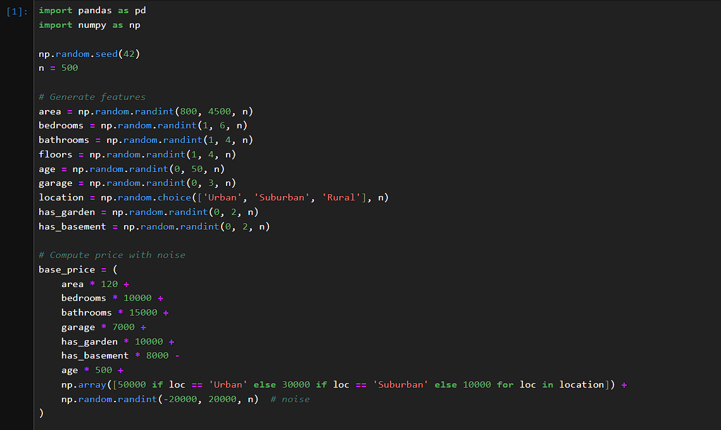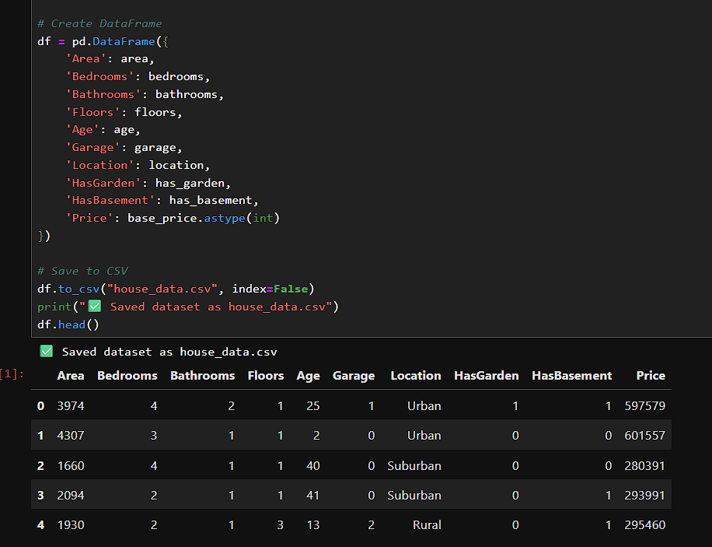
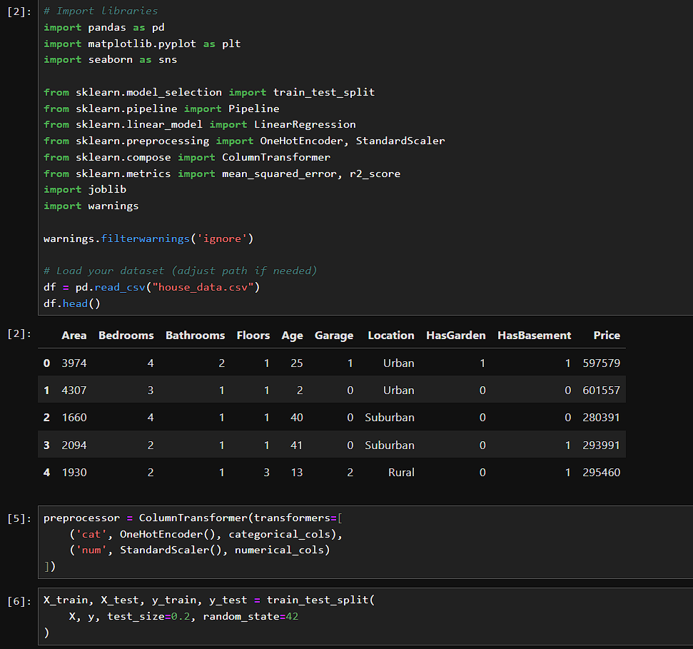
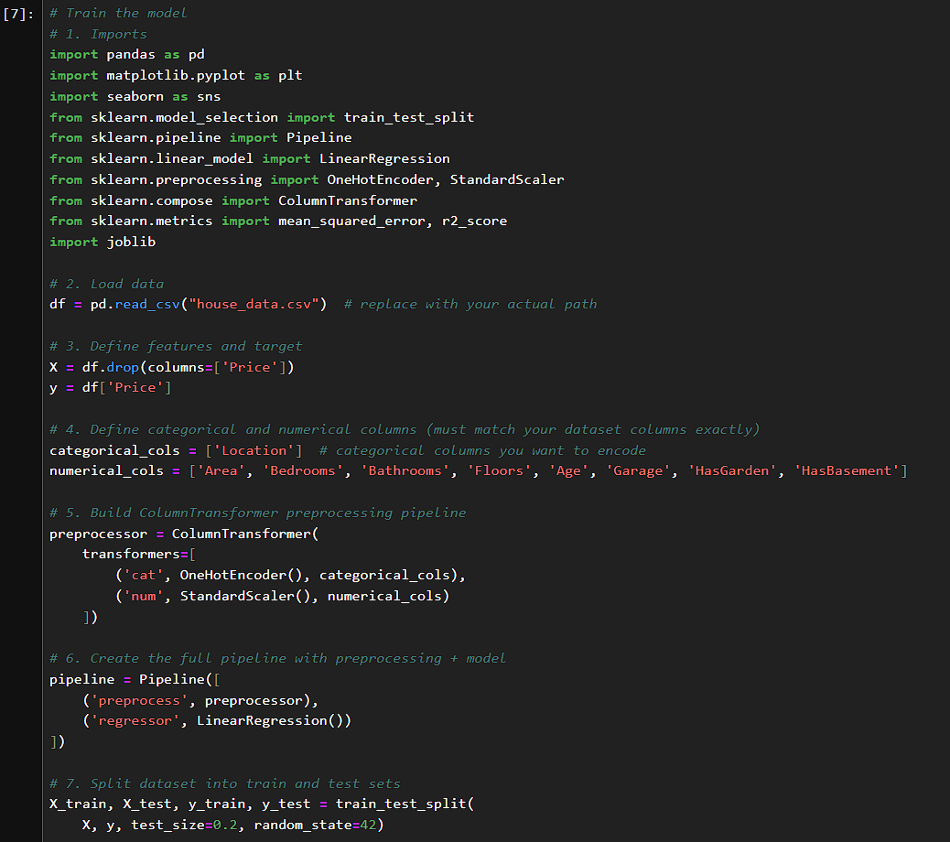

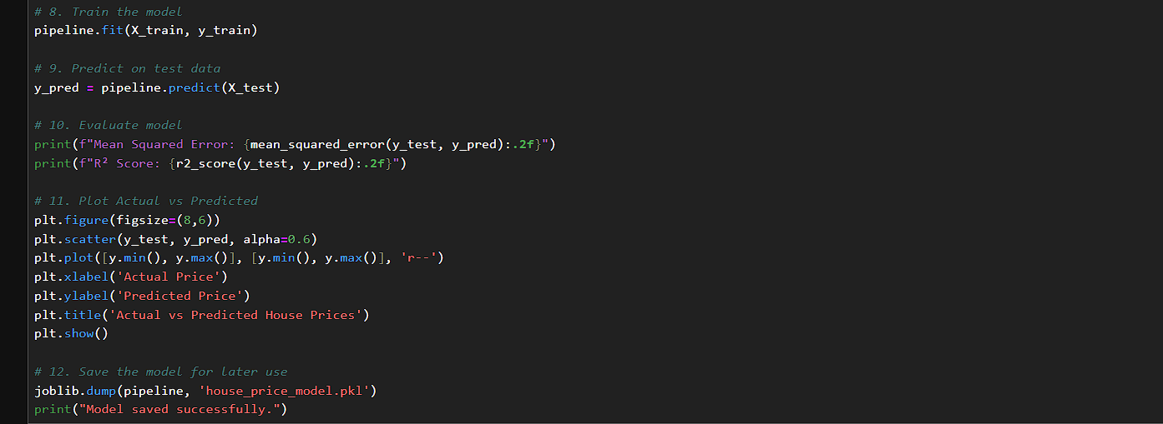
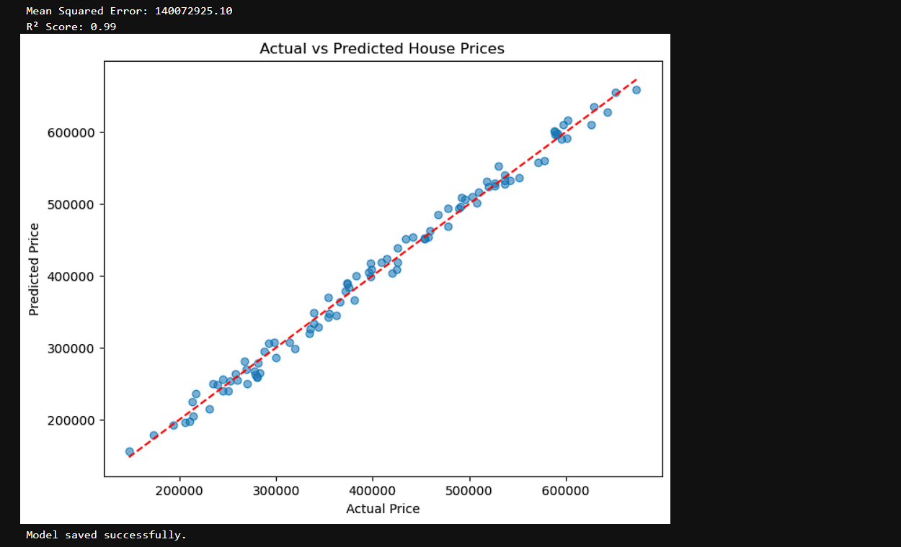

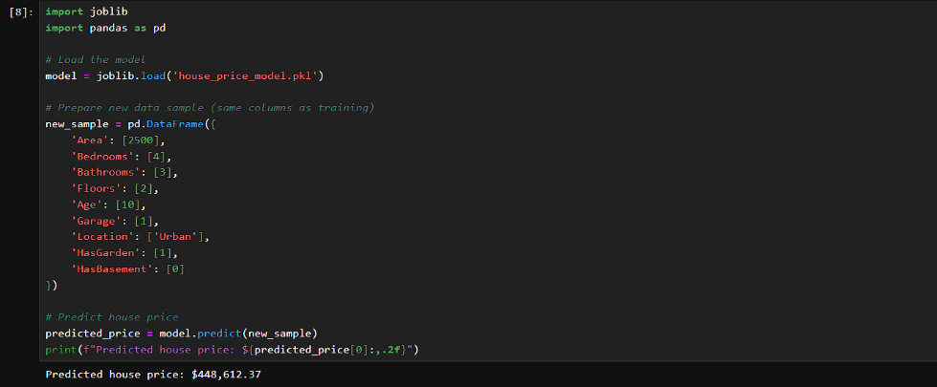

FRONTEND CODE

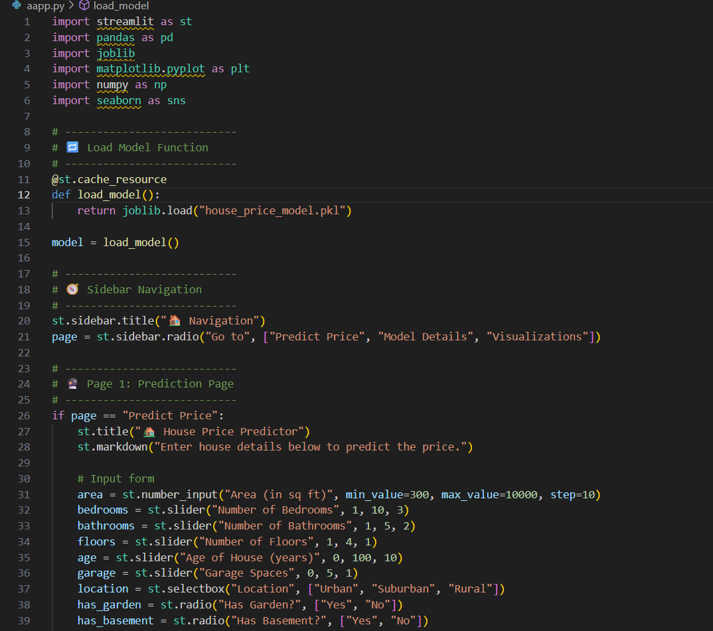

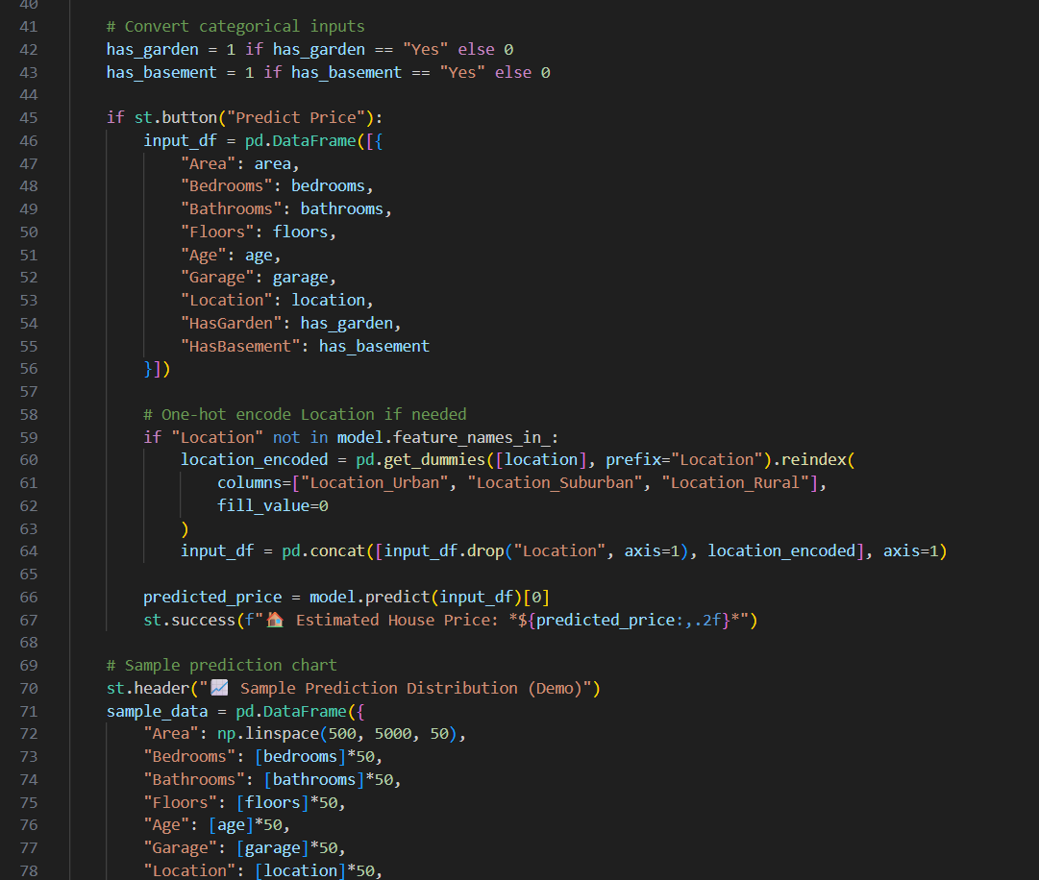
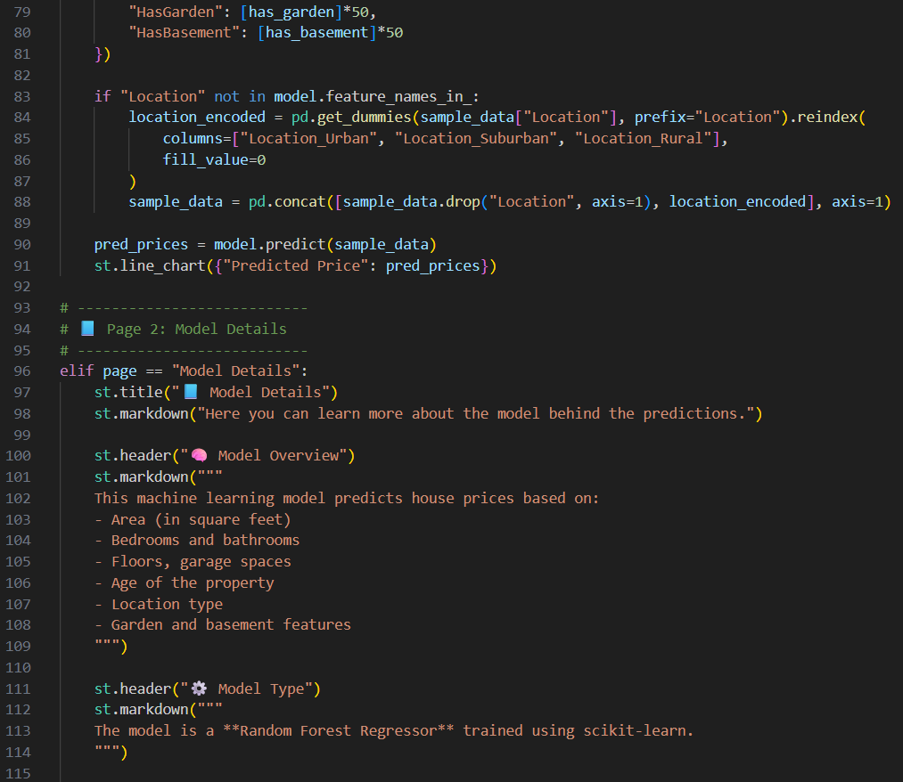

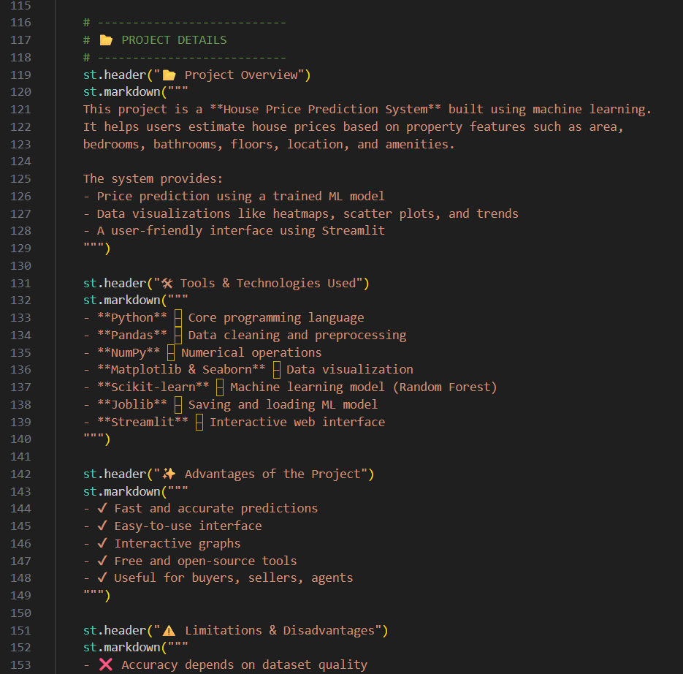
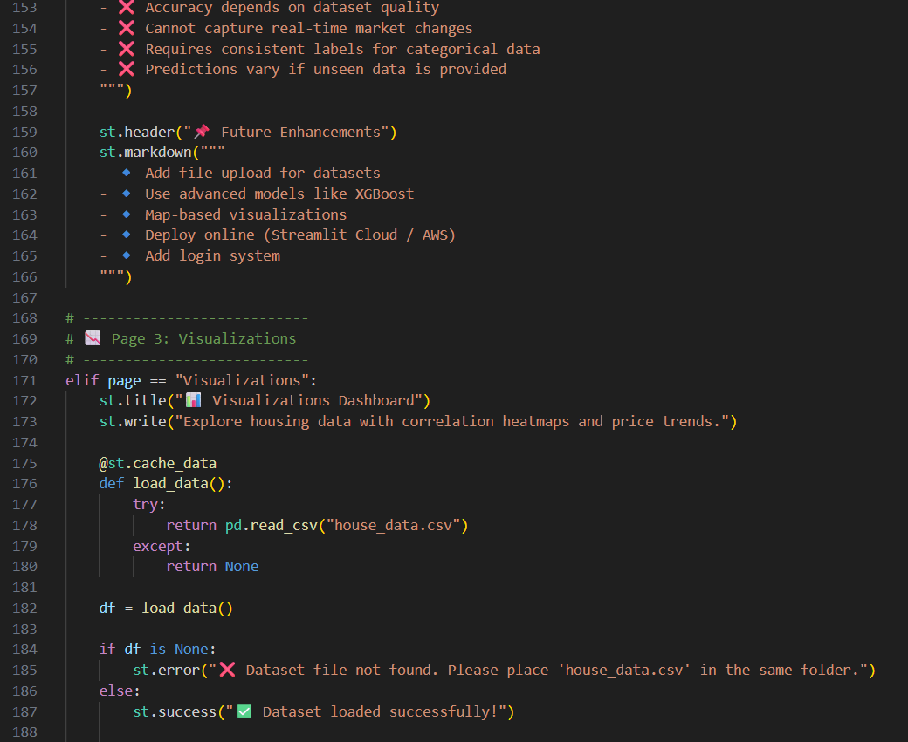
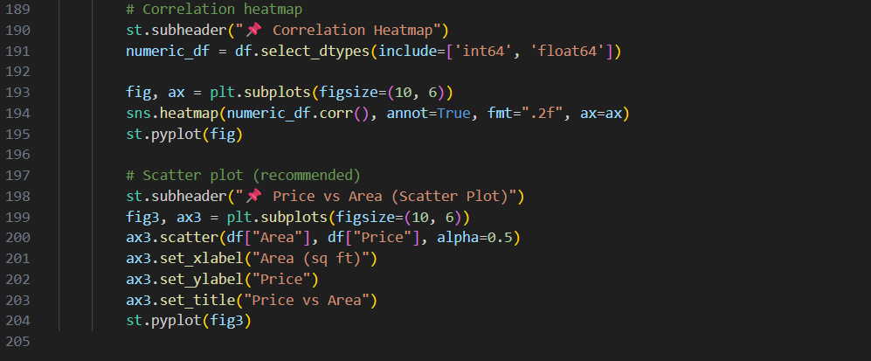

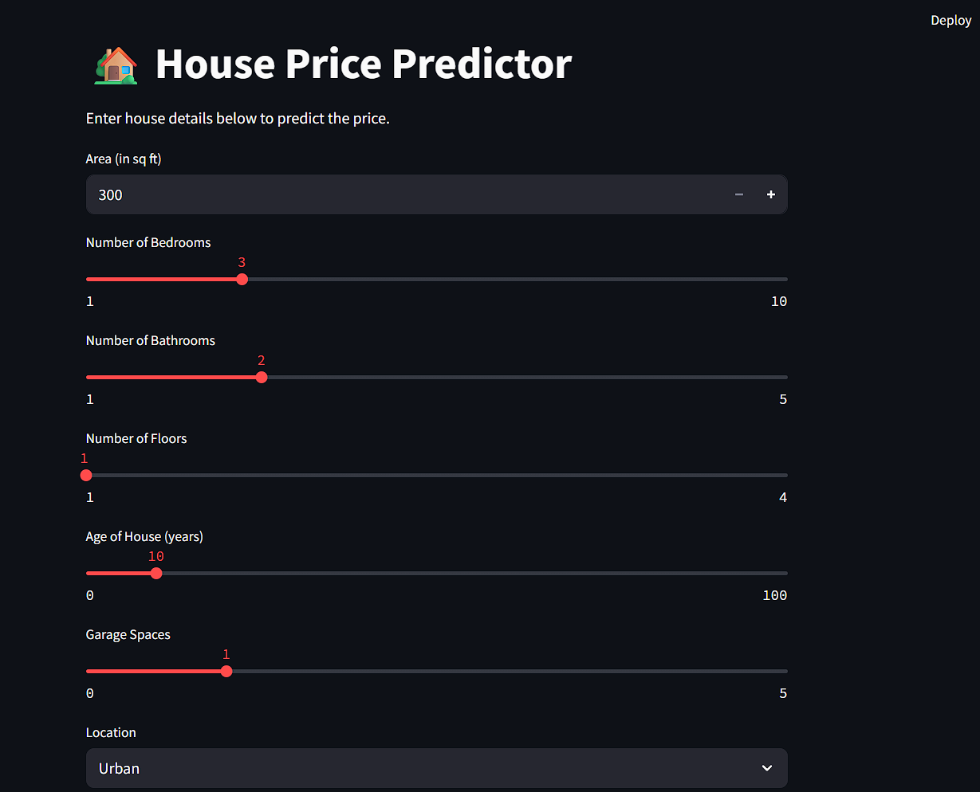
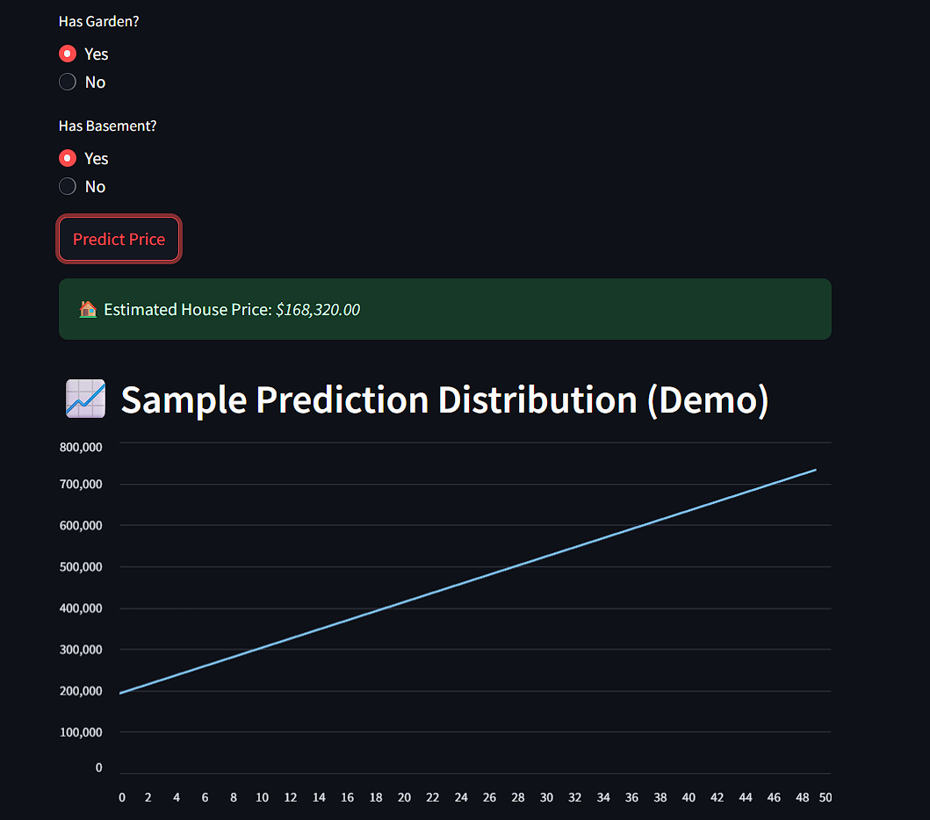

Applications

The House Price Prediction System built using Machine Learning has a wide range of real-world applications across the real estate, finance, construction, and data analytics sectors. It helps automate and improve decision-making related to property valuation, making the process more accurate, transparent, and data-driven.

Real Estate Agencies & Property Dealers

Real estate companies deal with hundreds of property listings every day. This system can assist them by:

Automatically estimating property prices based on location, area, number of bedrooms, bathrooms, and other features.

Helping agents provide accurate and instant price quotes to customers.

Reducing manual market research time by offering data-driven valuation.

Home Buyers & Sellers

Individuals planning to buy or sell a house can benefit from:

Quick price estimates without needing a professional valuation.

Better financial planning by understanding the market value of properties.

Comparing multiple properties to identify which one offers better value.

This helps buyers negotiate confidently and sellers price their homes correctly.

Banks & Financial Institutions

Banks and lenders can use the model to:

Assess property value before approving home loans.

Reduce risks associated with overvalued or undervalued property assessments.

Automate part of the loan approval workflow.

This enhances the efficiency of mortgage processing.

Real Estate Investment & Market Analysis Firms

Investment firms and analysts can use the system to:

Predict future property value trends.

Identify profitable areas for real estate investment.

Support data-driven decisions in buying, selling, or renting properties.

This improves portfolio management and investment strategies.

Construction & Developers

Builders and developers can use the model to:

Analyze which property features increase market value.

Decide the best price for new housing projects.

Estimate selling price before construction begins.

This helps in planning and pricing large-scale projects effectively.

Future Goals

The current House Price Prediction System provides accurate results using Linear Regression and essential property features. However, several improvements and advanced capabilities can be added to enhance the model’s performance, accuracy, and usability. The following future goals outline how the system can evolve into a more powerful and intelligent real estate prediction platform:

1. Integration of Advanced Machine Learning Models

Implement more sophisticated algorithms such as:

Random Forest

Gradient Boosting

XGBoost

Neural Networks

These models can significantly improve prediction accuracy, especially on large and complex datasets.

2. Inclusion of Additional Property Features

Add more real-world influencing factors such as:

Age of the building

Furnishing status

Parking availability

Nearby amenities (schools, hospitals, markets)

Crime rate and neighborhood quality

These additional features can help the model produce more reliable predictions.

3. Real-Time Price Prediction

Integrate APIs to fetch:

Live real-estate market trends

Location-based demand and supply

Government property tax data

This will allow real-time valuation instead of static predictions.

4. Geo-Spatial Mapping (GIS Integration)

Use map-based visualization to:

Show price distribution across cities

Display hot zones and investment-friendly areas

Provide location-based predictions using latitude and longitude

5. Build a Complete Web or Mobile Application

Create a full user interface where users can:

Enter property details

Compare multiple properties

Save historical predictions

Access personalized price recommendations

6. Cloud Deployment

Deploy the model on platforms like:

AWS

Google Cloud

Azure

This will make the prediction system accessible to users globally.

Conclusion

The House Price Prediction System developed using Machine Learning provides an efficient and accurate way to estimate property prices based on essential features such as location, size, bedrooms, bathrooms, and overall area. By applying Linear Regression, the model successfully identifies patterns and relationships within the dataset, enabling users to obtain reliable price predictions.

This project demonstrates how data-driven approaches can simplify complex decision-making in the real estate market. It not only reduces manual effort but also enhances transparency and accuracy in property valuation. The system can be highly useful for buyers, sellers, real estate agents, and investors who rely on accurate pricing for making informed decisions.

Overall, the project highlights the significance of Machine Learning in real-world applications and lays a strong foundation for building more advanced, intelligent, and scalable real estate prediction systems in the future.

References
- Géron, A. (2019). Hands-On Machine Learning with Scikit-Learn, Keras, and TensorFlow. O’Reilly Media.
  - Used for regression models, feature importance, and cross-validation concepts.
- Raschka, S., & Mirjalili, V. (2019). Python Machine Learning (3rd Edition). Packt Publishing.
  - Guidance on data preprocessing, model training, and evaluation metrics (R², RMSE, MAE).
- Scikit-learn Documentation. (n.d.). Machine Learning in Python. Retrieved from https://scikit-learn.org/stable/
  - Reference for implementation of train-test split, cross-validation, regression, and feature importance.
- Brownlee, J. (2016). Machine Learning Mastery with Python. Machine Learning Mastery.
  - Practical examples for regression models and performance evaluation in real datasets.

